cid:image001.jpg@01D1D790.341503F0



LKSOM is committed to helping students enhance their financial literacy skills. The expenses of medical school and beyond can be overwhelming. Money and finances often seem mysterious. To address issues of financial literacy, the Association of American Medical Colleges (AAMC) provides SALT, a free, online, financial education resource. A range of topics are offered in order to help you learn how to effectively manage your money.

Medical students have identified debt management as one of the most outstanding issues of concern so in order to help you understand your financial situation, LKSOM had developed a financial literacy program that will be tailored to individual student need. Each semester, you will be asked to complete a mandatory assignment (8 total while attending LKSOM). To start this process**,** prior to matriculation, we are asking you to complete the SALT ‘Budgeting’ lesson. This should take approximately 30 minutes to complete. Please submit your Certificate of Completion via email to [sfsmed@temple.edu](mailto:sfsmed@temple.edu) by **Friday, July 28th**.

Instructions for gaining access and completing assignments:

1. Sign up for your **free** account at [www.saltmoney.org](http://www.saltmoney.org). Be sure to indicate your **Affiliation** as ‘**Organization**’ and enter **Association of American Medical Colleges**. Indicating this affiliation gives you your free membership.
2. When signed in, click ‘Budgeting’ under Salt Courses on the right-hand side

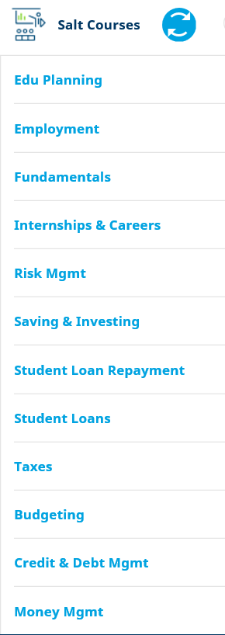

1. Click ‘Budgeting Lesson’ and go through the tutorial
2. Once done, click ‘Budgeting Examination’ and answer the 15 questions
3. Once successfully completed the exam, complete the evaluation and survey click ‘Get your certificate’

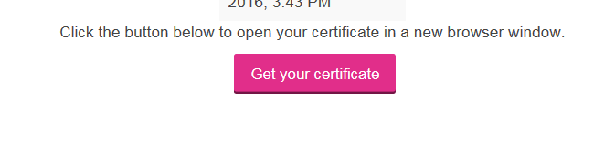

1. Save certificate pdf as LastnameFirstname (ie. SmithJohn) and email it to [sfsmed@temple.edu](mailto:sfsmed@temple.edu) with the subject line **Class of 2021 SALT Fall 2017**.

** Questions? Contact Student Financial Services at 215-707-0749 / 215-707-7846 or [sfsmed@temple.edu](mailto:sfsmed@temple.edu) **